STANDARD FORMAT OF “LEHENGA DESCRIPTION”


For Online Selling Products
Design Name: ROYAL-A
Product Colours NO.: A1
. 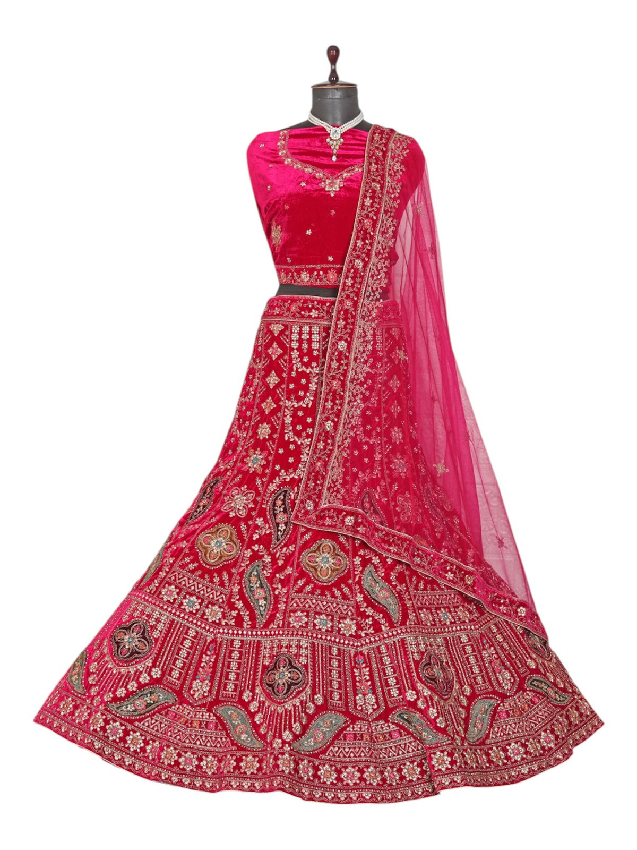
Particulars | Details
Lehenga Fabric | Velvet
Blouse Fabric | Velvet
Dupatta Fabric | Net
Work Type | Jari, Jarkan & Thread embroidery Work
Colour | Rani
Pattern | Bridal Designer Lehenga
Stitching Type | Semi-Stitched (Can be customized up to 44")
Occasion | Wedding, Reception, Engagement & Festive Wear
Fit Type | Regular Fit
Care Instructions | Dry Clean Only
Package Contents | 1 Lehenga, 1 Blouse Piece, 1 Dupatta

KEY HIGHLIGHTS
- Made from premium velvet fabric for a rich, royal appearance
- Detailed with Jari, Jarkan, and thread embroidery
- Comes with a soft net dupatta adding graceful elegance
- Ideal for weddings, receptions, and festive celebrations
- Semi-stitched design ensures easy customization and fitting
- Regular fit provides comfort for long functions
- A perfect blend of traditional craftsmanship and modern bridal style

